|  |
| --- |
| Business Case Summary |
| Muhammad Faraz – Business Analyst – Digital Empowerment Network |

Date: 28 Aug, 2024

# Nestlé Pakistan

**Company Background** 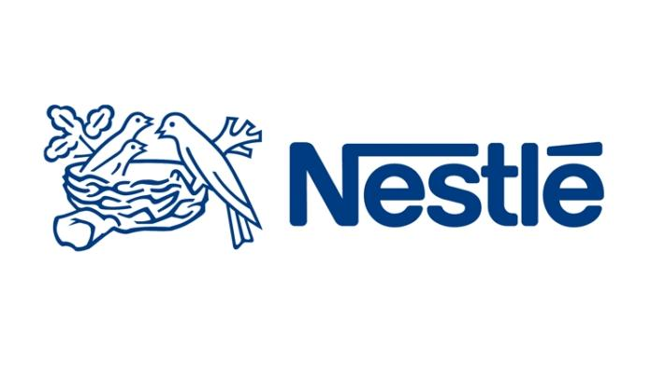Nestlé Pakistan, a subsidiary of the global food and beverage giant, Nestlé, operates in a water-scarce country where efficient water management is crucial. The company is committed to improving its water use efficiency across its operations, especially considering Pakistan’s decreasing water availability due to factors like population growth, urbanization, and climate change.

**Problem or Challenge**

Pakistan faces a critical water scarcity issue, which is exacerbated by rising population, urbanization, and climate change. For Nestlé Pakistan, a company deeply embedded in the agricultural sector, this challenge is particularly pressing. Efficient water management is necessary to ensure the sustainability of its operations and the broader value chain, particularly in dairy farming, which is a major part of its business.

**Solution or Strategy**

Nestlé Pakistan has implemented several strategies to address the water scarcity issue:

1. **Water Recycling and Wastewater Management**: The company has optimized its water use by recycling water in its operations. In Sheikhupura, for example, water is extracted from fresh milk, which is 87% water, and reused after evaporating it during the milk powder production process. The company’s factories also treat wastewater in compliance with the National Environmental Quality Standards (NEQS) before disposal.

1. **Sustainable Agriculture Initiatives**: Nestlé has introduced water-saving technologies in collaboration with the Center for Water Informatics and Technology at Lahore University of Management Sciences (LUMS). This includes the Water Sense technology, which helps farmers monitor soil moisture levels and optimize irrigation, resulting in better crop yields and water savings.
2. **Drip Irrigation**: Nestlé Pakistan is exploring and facilitating the use of drip irrigation, which is more water-efficient compared to traditional flood irrigation. The company has supported the installation of drip irrigation systems on 93 acres of farmland in Sheikhupura, which is expected to save 140 million liters of water annually.
3. **Stakeholder Engagement**: Nestlé Pakistan actively engages with various stakeholders, including farmers, government institutions, and non-profit organizations, to promote water stewardship. The company has partnered with LUMS to fund research and innovation in water management, and collaborates with entities like the Pakistan Agriculture Research Council and WWF.

**Outcome or Results**

Nestlé Pakistan’s initiatives have led to significant improvements in water use efficiency. The Water Sense technology has not only improved crop yields but is also expected to save up to 12% of water used in farming. The company’s drip irrigation initiative is anticipated to save substantial amounts of water annually. Additionally, Nestlé Pakistan has installed six water filtration plants, providing safe drinking water to approximately 60,000 people across the country.

**Key Takeaways**

- **Innovative Water Management:** Companies operating in water-scarce regions can significantly reduce their environmental impact by adopting innovative water recycling and conservation strategies.

- **Collaborative Efforts:** Engaging with stakeholders, including academic institutions, government bodies, and NGOs, can enhance the effectiveness of sustainability initiatives.

- **Technology in Agriculture:** Implementing advanced technologies, like Water Sense and drip irrigation, can lead to more sustainable agricultural practices and significant resource savings.

Nestlé Pakistan’s case illustrates how companies can align their operations with environmental stewardship while ensuring business sustainability.